Experiment

**Bulb Control using NodeMCU via Wi-Fi interface**

NodeMCU

* NodeMCU is an open-source firmware and development kit that enables the development of IoT (Internet of Things) projects using the ESP8266 Wi-Fi module. It combines both hardware and software elements to provide a platform for building connected devices and applications.
* NodeMCU is built around the ESP8266 module, which is a low-cost Wi-Fi microcontroller with integrated TCP/IP protocol stack.
* The ESP8266 module is the heart of NodeMCU and provides the processing power and Wi-Fi connectivity needed for IoT applications.
* NodeMCU offers built-in Wi-Fi support, enabling devices to connect to local networks and the internet.

Arduino

* Arduino Integrated Development Environment (IDE) is an open-source software platform designed for writing, compiling, and uploading code to Arduino microcontroller boards. It simplifies the process of programming microcontrollers, making it accessible to beginners and experienced developers alike.
* The IDE supports a wide range of Arduino boards, including the popular Arduino Uno, Arduino Mega, and many others.
* Users can select the appropriate board when writing code, ensuring compatibility.
* Arduino IDE includes a vast library of functions and examples that simplify common tasks.
* Users can access pre-written code for sensors, actuators, displays, and more, reducing the need to start from scratch.

Device Manager

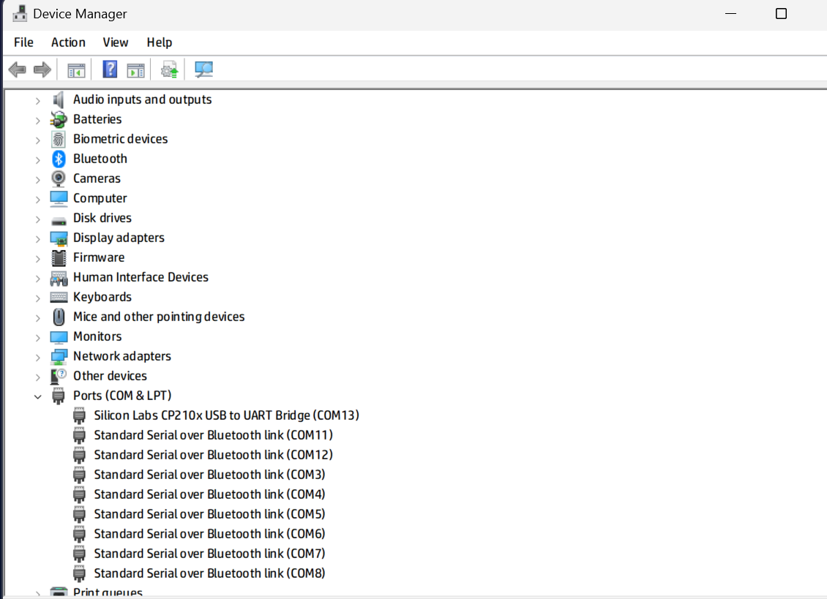

Board and Port configuration

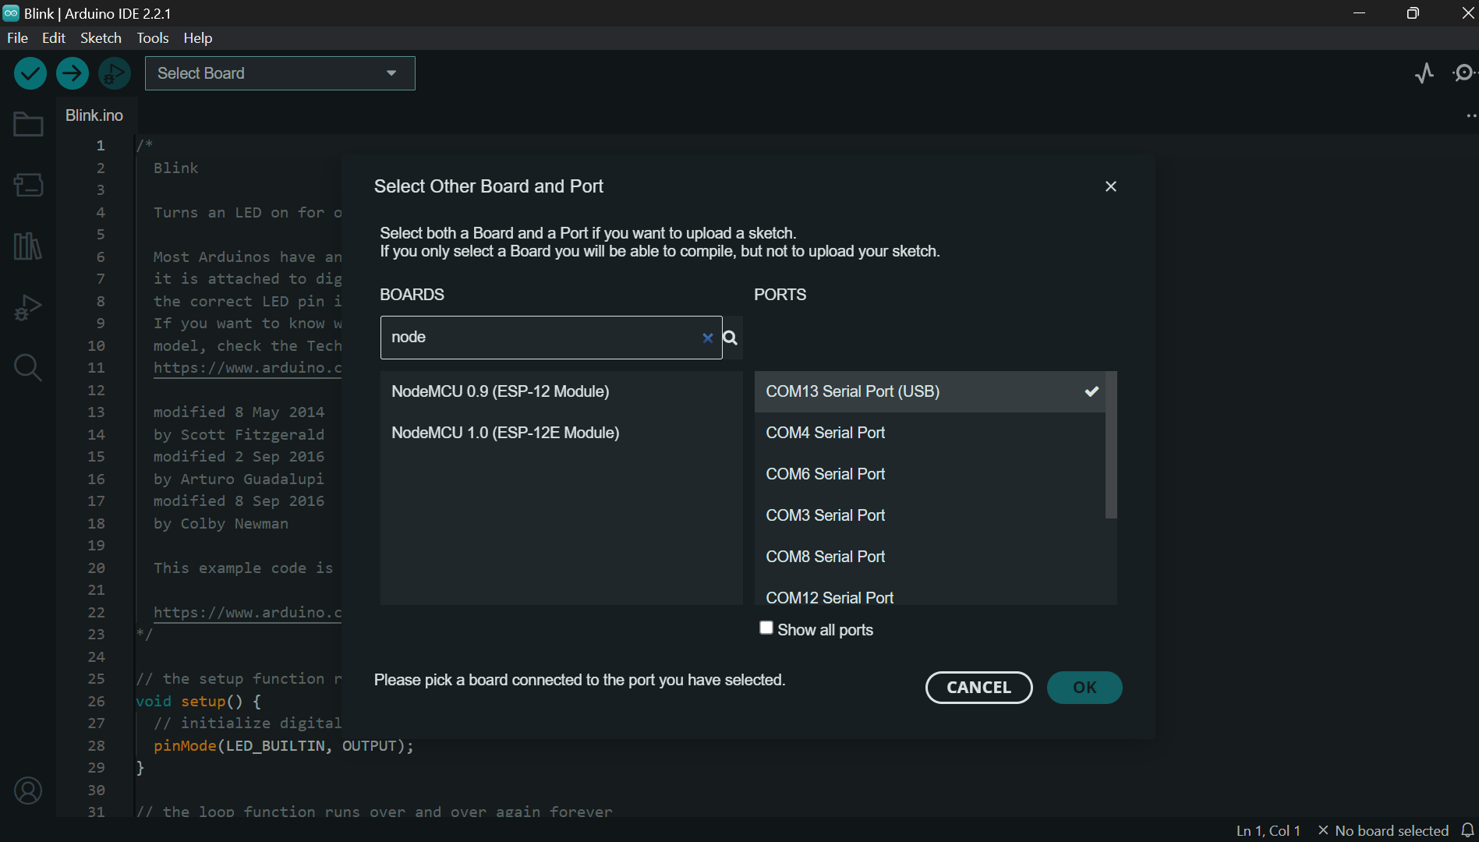

Arduino Sketch

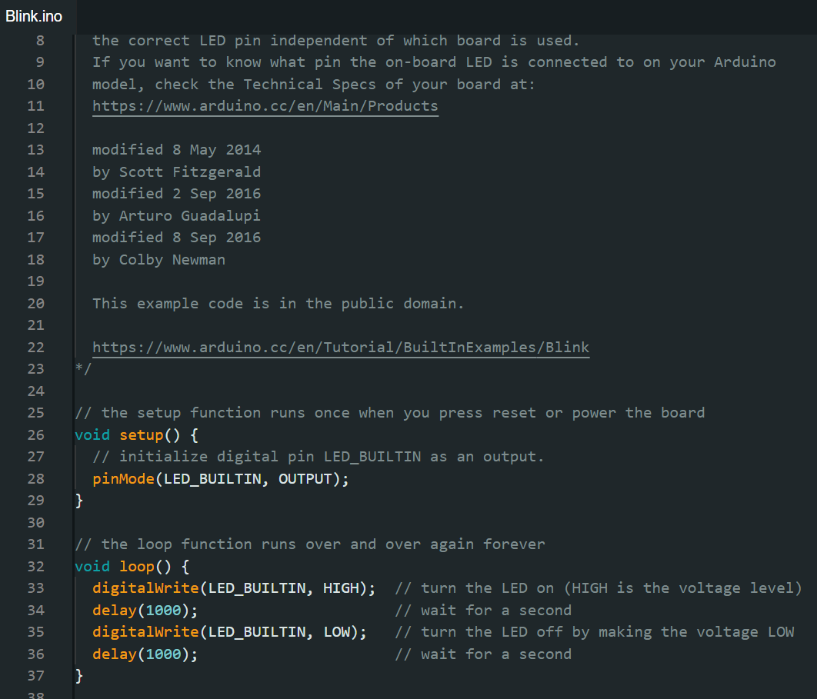

Circuit board Simulation

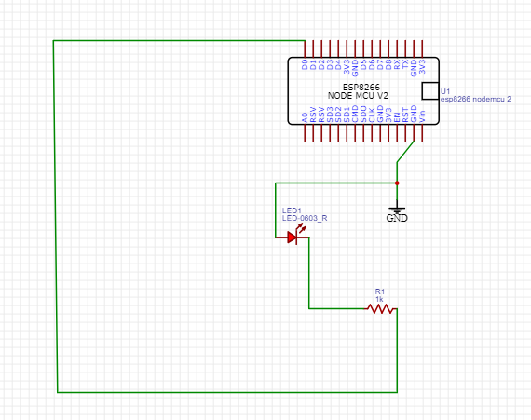

Layout

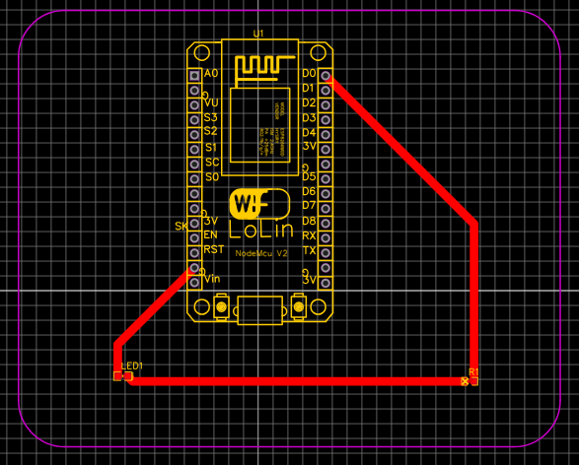

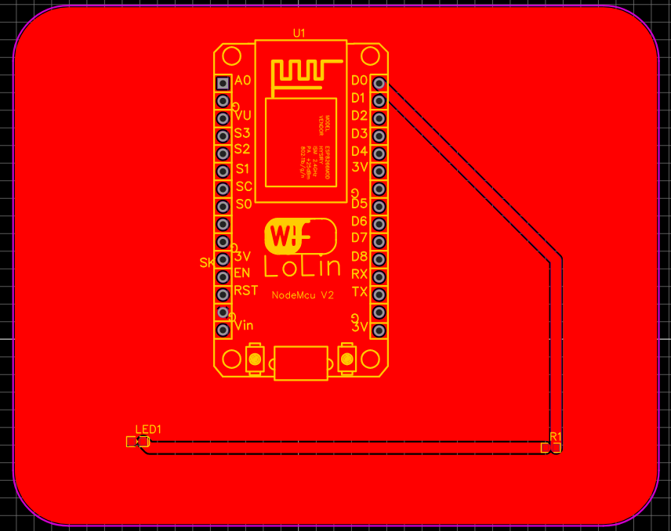

Submitted By – *Gopala Krishna Abba*